

Final Term Project

# INTRODUCTION TO DATA SCIENCE [C]

**Submitted By: Group 8**

**Members Name:**

1. **MD. RAIYAN AL SULTAN**

**Id: 19-41639-3**

1. **MEDHA CHOWDHURY**

**Id: 20-41930-1**

**Section: C**

**Submitted to: TOHEDUL ISLAM Sir**

# Data Set name: Stroke Prediction Dataset

# About the Data Set:

According to the World Health Organization (WHO) stroke is the 2nd leading cause of death globally, responsible for approximately 11% of total deaths.

This dataset is used to predict whether a patient is likely to get stroke based on the

input parameters like gender, age, various diseases, and smoking status. Each row

in the data provides relevant information about the patient.

Dataset link: https://www.kaggle.com/datasets/fedesoriano/stroke-prediction-dataset?resource=download

GitHub link of our project: https://github.com/NabilRaiyan/Stroke-Prediction

### **Attribute Information:**

1) id: unique identifier  
2) gender: "Male", "Female" or "Other"  
3) age: age of the patient  
4) hypertension: 0 if the patient doesn't have hypertension, 1 if the patient has hypertension  
5) heart_disease: 0 if the patient doesn't have any heart diseases, 1 if the patient has a heart disease  
6) ever_married: "No" or "Yes"  
7) work_type: "children", "Govt_jov", "Never_worked", "Private" or "Self-employed"  
8) Residence_type: "Rural" or "Urban"  
9) bmi: body mass index  
10) smoking_status: "formerly smoked", "never smoked", "smokes" or "Unknown"*  
11) stroke: 1 if the patient had a stroke or 0 if not

Here stroke is target attribute.

GitHub link of our project:

Importing the data set: Importing csv format of the data set in R studio.

Code:



Output:



Inspecting the data set: In this code we are inspecting the data set using head(), tail(),

Summary(), names(), dim(), is.na(), colSums() amd str() method.

Code:

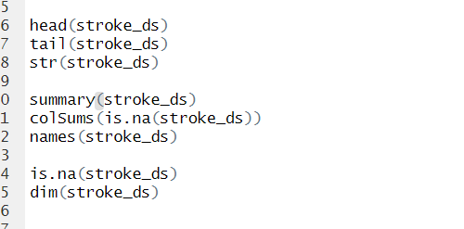

Output:

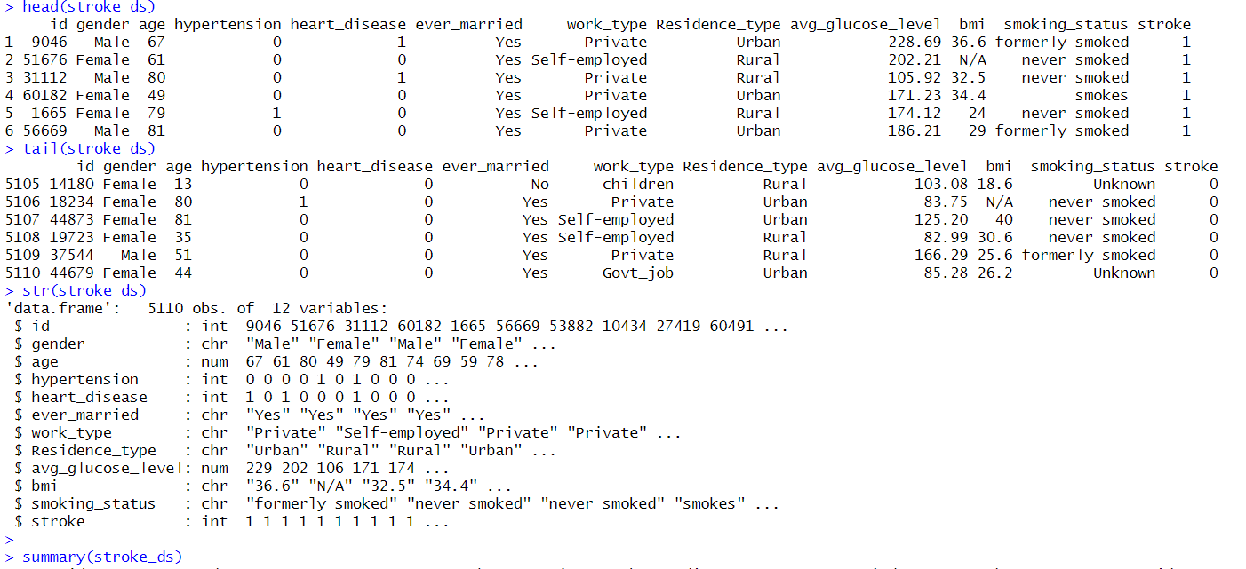

Preparing the data set:

**Gender Column:**

In this part of the code we convert “Male” and “Female” with 1 and 0 to find the missing value and then we find the row of the missing value and recover that row of missing value with mode value.

Code:

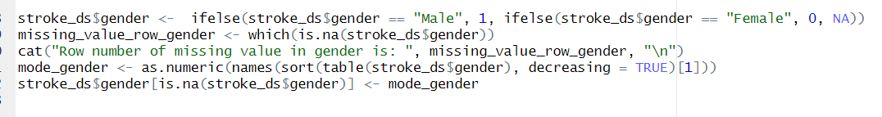

Output:

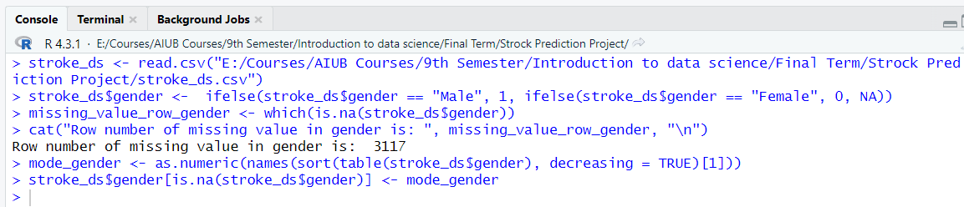

**Bmi Column:**

In this part of code we convert N/A into NA and find missing value’s row and also find mode value and recover those missing value rows with mode. Then we find outliers and also recover those outliers with mode value.

Code:

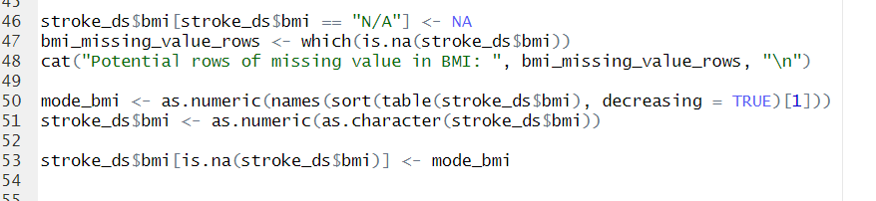

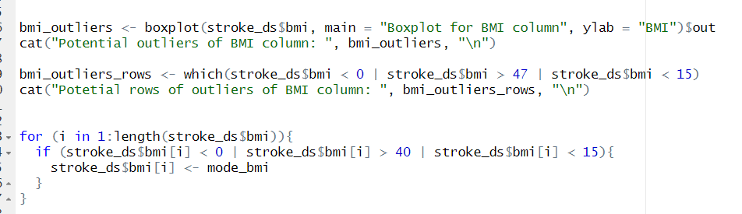

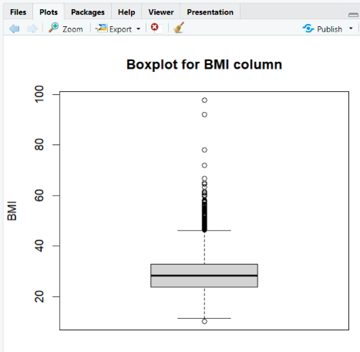

Output:

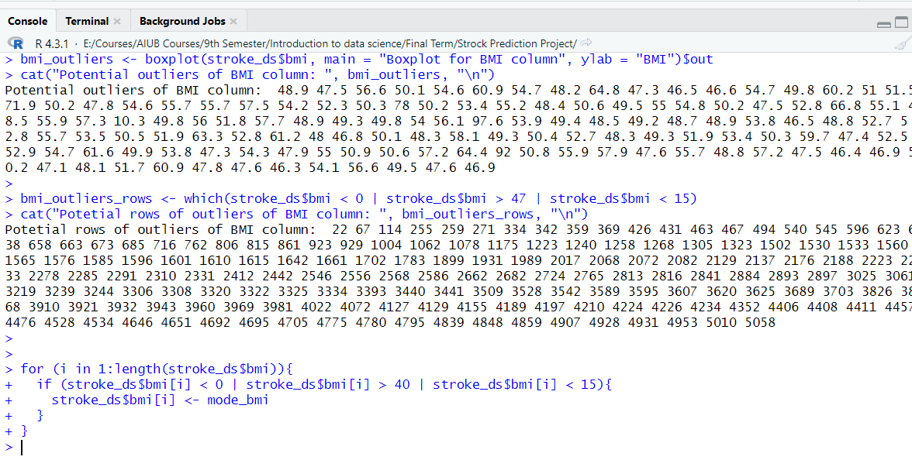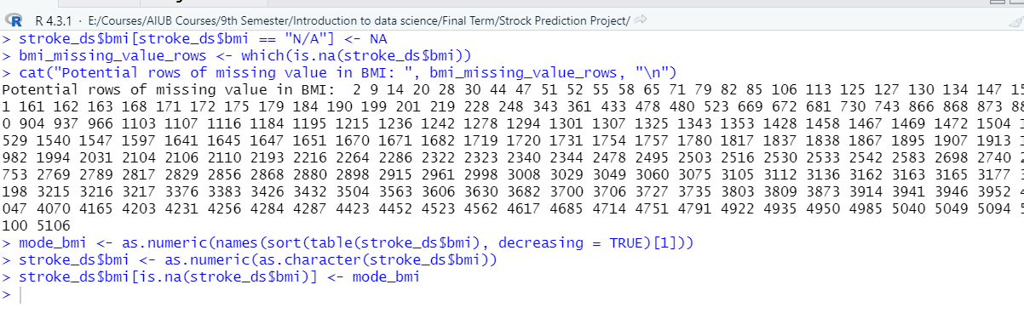

**Smoking Status column:**

In this part of code, we find the mode value of smoking status column and recover the Unknown rows with mode value.

Code:



Output:

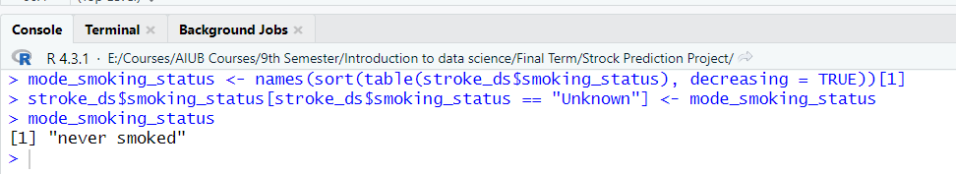

Converting into categorical value:

Avg glucose level column:

In this code we convert the avg_glucose_level column into categorical attribute.

Glucose levels are categorized as follows:

1. "Low" for values less than or equal to 50
2. "Medium" for values between 51 and 100
3. "High" for values greater than 100

Code:



Output:



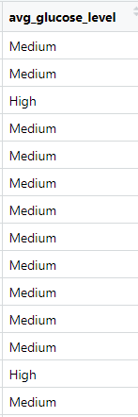

Age column:

In this code we convert the age column value into categorical value.

Ages are categorized as follows:

1. “0-18” to Children
2. “19-35” to Adults
3. “36-50” to Middle age adult
4. 51++ to Senior adult

Code:



Output:





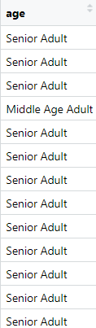

Bmi Column:

In this code we convert the bmi column value into categorical value.

Bmi are categorized as follows:

1. “0-18.5” to Underweight
2. “18.6-24.9” to Normal weight
3. “25-29.9” to Overweight
4. “30++” to Obese

Code:

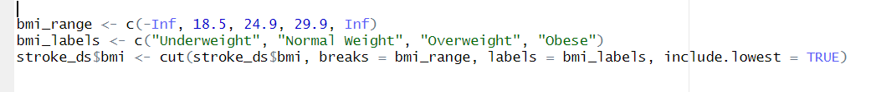

Output:

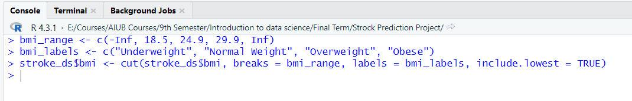

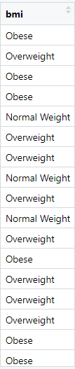

**Applying correlation technique** (**Pearson's Chi-squared test**):

**Id column:** In this part we apply **Pearson's Chi-squared test** onId column and find that the value of p is 0.4934 which is greater than 0.05. So, this column is insignificant and later we will delete this column.

Code:

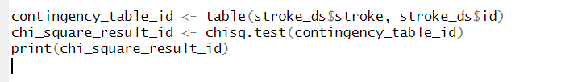

Output:

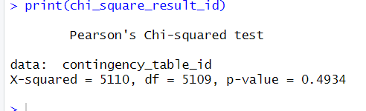

**Gender Column:** In this part we apply **Pearson's Chi-squared test on** gender column and find that the value of p is 0.558 which is greater than 0.05. So, this column is insignificant and later we will delete this column.

Code:

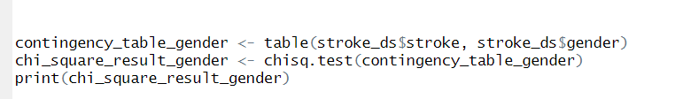

Output:

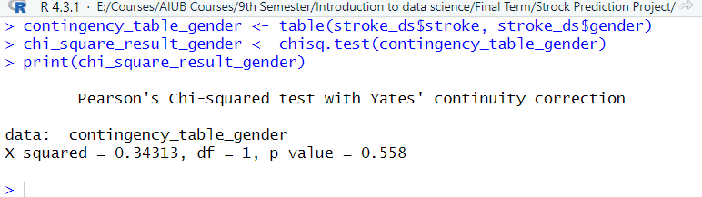

**Age column**: In this part we apply **Pearson's Chi-squared test** onage column and find that the value of p is 2.2e-16 which is less than 0.05. So, this column is significant.

Code:

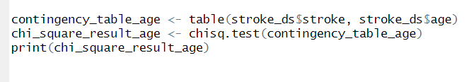

Output:

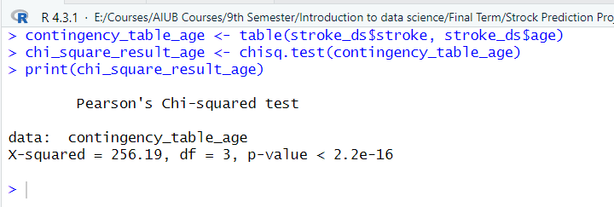

**Hypertension Column:** In this part we apply **Pearson's Chi-squared test** on hypertension column and find that the value of p is 2.2e-16 which is less than 0.05. So, this column is significant.

Code:

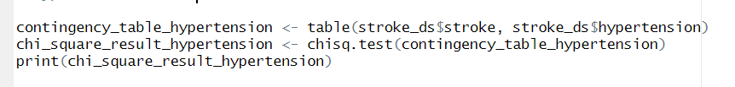

Output:

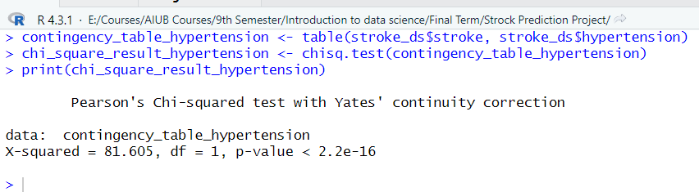

**Heart Disease column:** In this part we apply **Pearson's Chi-squared test** on heart disease column and find that the value of p is 2.2e-16 which is less than 0.05. So, this column is significant.  
Code:

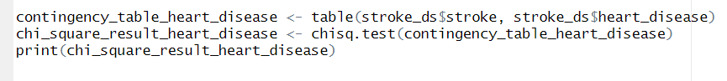

Output:

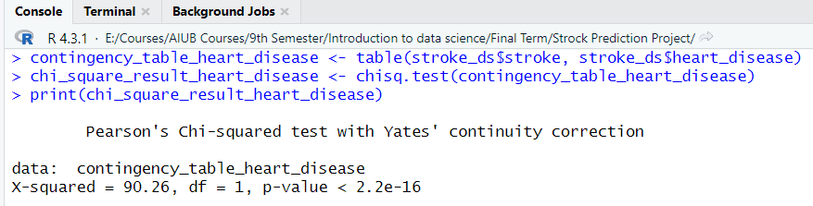

**Ever married column:**

In this part we apply **Pearson's Chi-squared test** on ever married column and find that the value of p is 1.639e-14 which is less than 0.05. So, this column is significant.

Code:

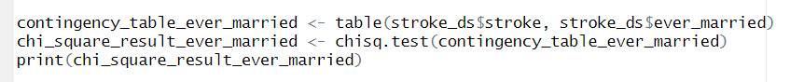

Output:

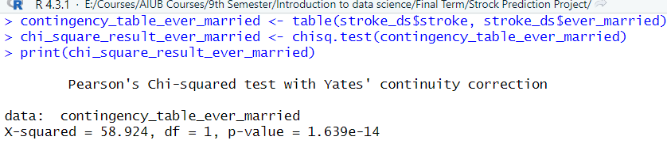

**Work Type column:**

In this part we apply **Pearson's Chi-squared test** on work type column and find that the value of p is 5.398e-10 which is less than 0.05. So, this column is significant.

Code:

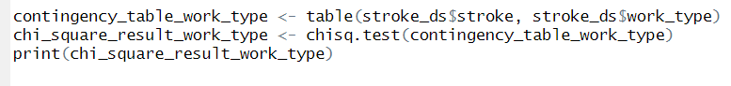

Output:

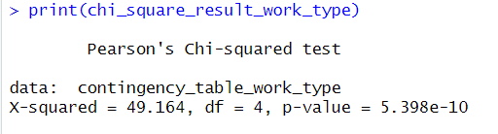

**Residence Type column:** In this part we apply **Pearson's Chi-squared test** on residence type column and find that the value of p is 0.2983 which is greater than 0.05. So, this column is insignificant and later we will delete this column.

**Code:**



**Output:**

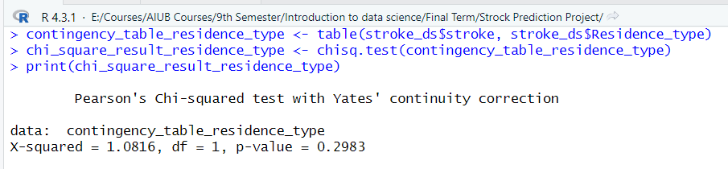

**Bmi Column:** In this part we apply **Pearson's Chi-squared test** on bmi column and find that the value of p is 6.324e-8 which is less than 0.05. So, this column is significant.

Code:

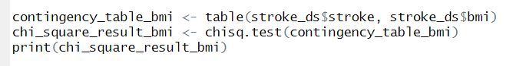

Output:

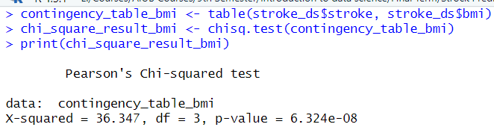

**Smoking Status Column:** In this part we apply **Pearson's Chi-squared test** on smoking status column and find that the value of p is 6.906e-06 which is less than 0.05. So, this column is significant.

Code:



Output:

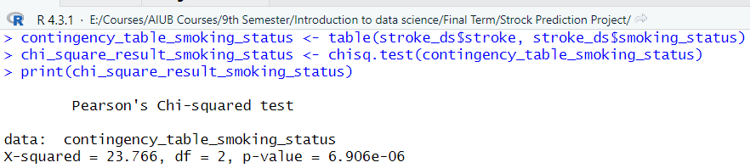

**Deleting Insignificant column from the data set:**

In this part we delete the insignificant column such as Id, gender from our dataset.

Code:



Output:

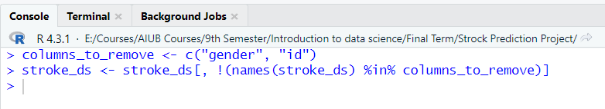

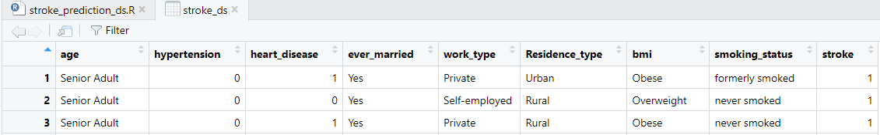

**Converting 0 and 1 of Stroke column data into Yes and No:**

In this part of code we convert stroke column’s 0 and 1 into Yes and No so that we can apply Naïve Baise algorithm on the dataset.

If 1 then “Yes”

If 0 then “No”

Code:



Output:



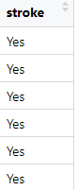

Applying Naïve Bayes classification algorithm to the dataset:

In this part of code, we are applying Naïve Bayes classification algorithm on our dataset and also we find the predictive accuracy of the Naïve Bayes classifier using approach 1 which is dividing the dataset into train and test data

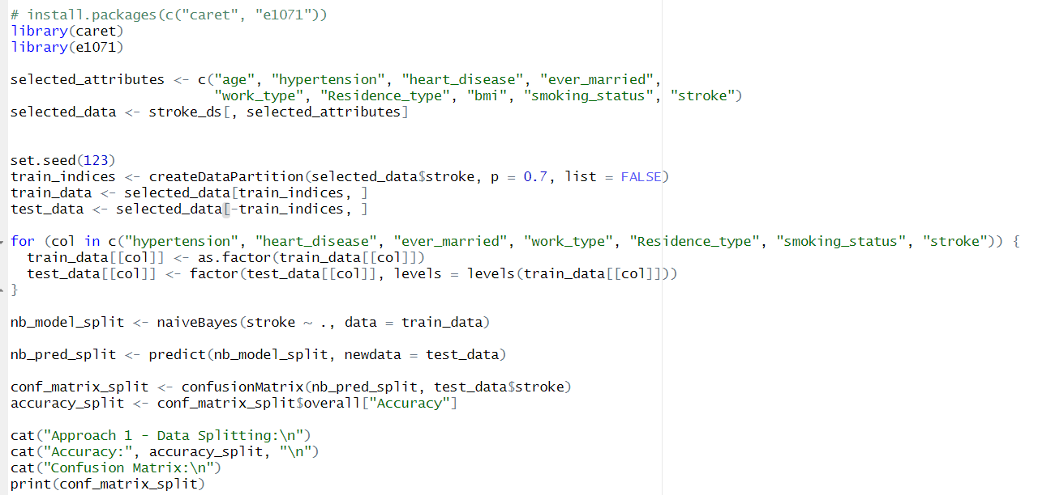Code:

Output:

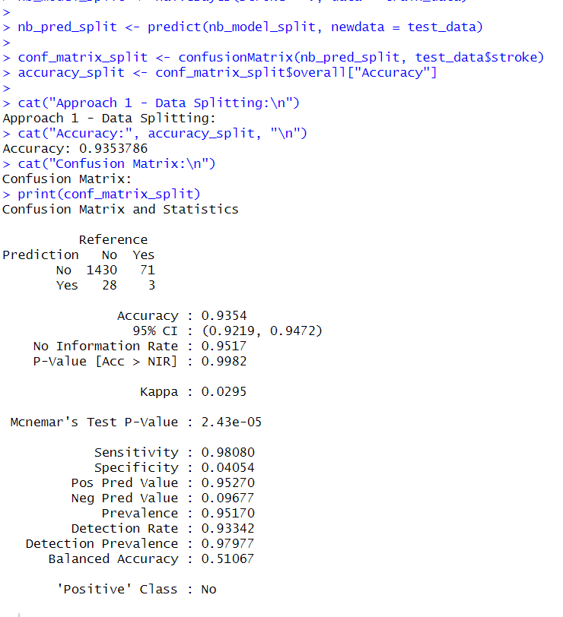

**Using 10-fold cross validation:**

In this part of code, we are applying 10-fold cross validation on our dataset to find the predictive accuracy of Naïve Bayes classifier.

Code:

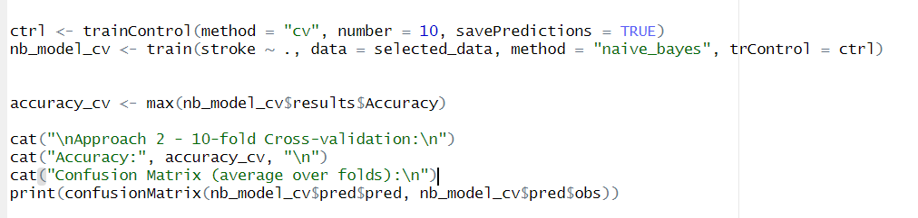

Output:

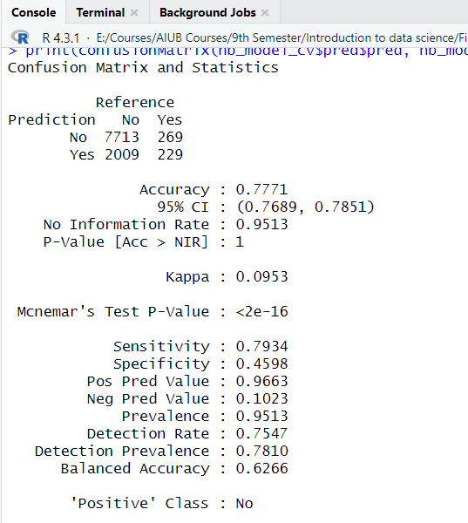

**Generating Confusion matrix for our dataset:** In this part of code we generate the confusion matrix for our dataset and also reporting the Recall, Precision and F- measure value of our classifier.

Code:

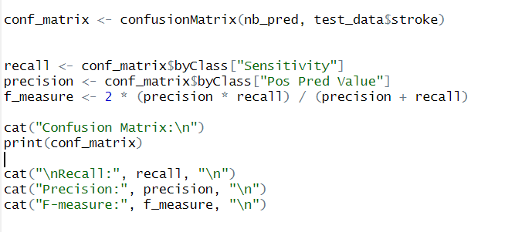

Output:

